HomeWork Multiple Year Stock Data Week 2

ScreenShot

Year -2014

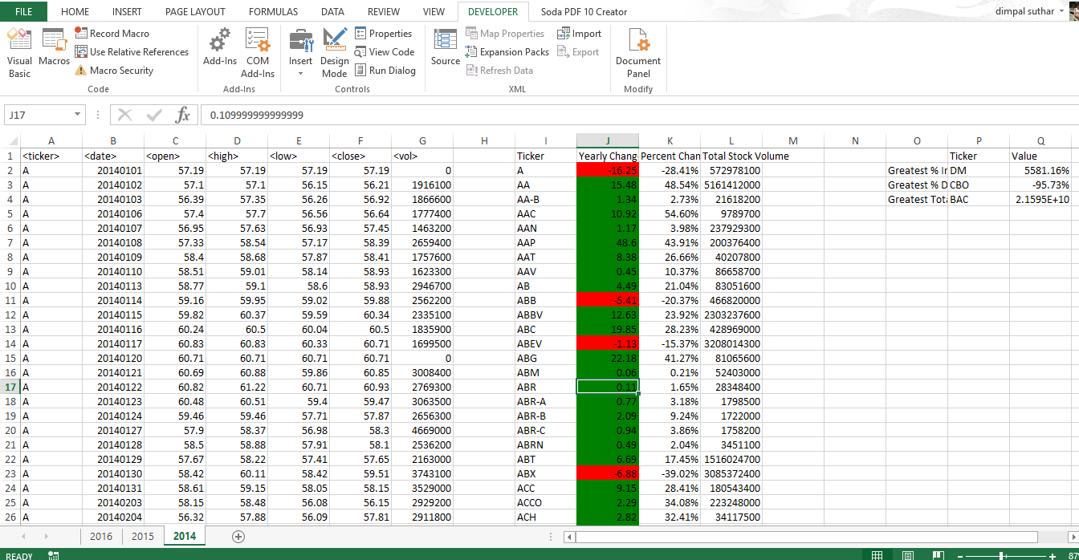

Year – 2015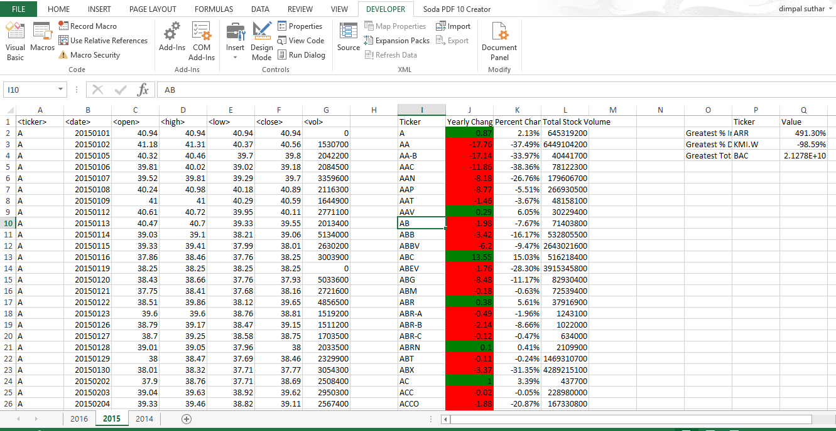

Year -2016

